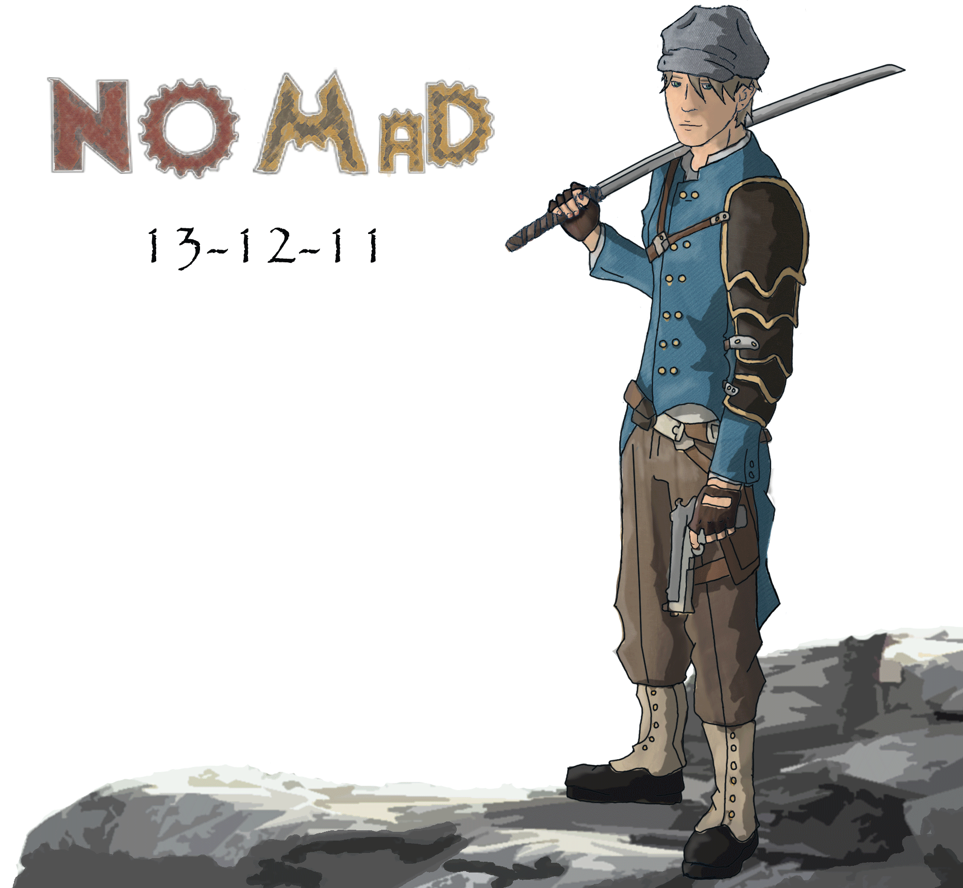

**Tag Line:**

“From the ashes of the old world, a new breed of civilization is born.”

**Platform & Engine:**

Single player game for the PC using the Unreal Engine.

**Genre:**

Adventure-RPG

**High Concept:**

The rampant consumption of the industrial revolution has rendered the conventional city obsolete as fast as it built them up. Now, mobile cities, called nomads, roam the world in search of new resources and technology. Aboard one such city it’s checkered past is about to catch up with it.

**Gameplay:**

*Nomad* is a 3rd person Adventure-RPG. The player’s character will have access to both ranged and melee attacks as well as a selection of unique special abilities based on steam technology. The character will level up by completing quests and defeating enemies. As he levels up he gains points which may be spent to advance down skill trees which enhance his capabilities in three distinct aspects of combat; ranged attacks, melee attacks, and survivability.

The player will encounter waves of enemies as well as bosses as he moves throughout the game world.

**Setting:**

The world of *Nomad* is a steam-punk style world where pollution and overconsumption has forced the development of mobile cities. The player’s city finds itself threatened by an exiled former researcher who has used steam technology to re-animate the dead and create an army. The primary enemies in the later stages are the twisted creations of the Exile; though they do appear sparingly in the earliest areas.

The game world is divided into 3 distinct zones, each with unique features and enemies. The first zone is a wintery mountain valley where the nomad {named IronSide} has spent the winter mining coal and hunting game. Second, the IronSide travels through a badlands and the player must fend off attacks and scavenge for scarce resources. The final zone is in the ruins of an old city that has been taken over and converted to a clockwork fortress.

**Character:**

The player’s character is a silent protagonist. When first created the player will have the ability to choose a name for the character as well as customize the colors of the character’s clothes.

At character creation there is no selection of a character’s class. Instead, all characters have access to the same 3 skill trees; melee, ranged, and survivability. The character’s unique abilities are also determined by the items that are equipped in the two steam equipment slots in the characters inventory. These add abilities like emitting a cloud of steam to damage nearby enemies, or deploying a temporary shield to act as a secure firing position.